**GENERAL HUMAN BIOLOGY – YEAR 12**

**TASK 1 – SCIENTIFIC METHOD EXERCISE PRACTICAL**

**\*\*Modified Assessment**

**NAME: ___________________________________ WEIGHTING: 4%**

**DATE: ______________________________ MARK: _____ / = 43**

***BACKGROUND INFORMATION***

Your physical work capacity is a measure of your ability to do physical work. You determine it by measuring your cardiovascular fitness. You can think of your cardiovascular fitness as the sum of the heart muscle fitness, blood vessel efficiency and ventilator muscle fitness. You can improve cardiovascular fitness with a regular exercise program.

The cardiovascular system circulates blood throughout the body, which supplies muscles with oxygen and other nutrients whilst removing waste products. Each time the heart beats; blood is either pumped out of the heart to the body or to the lungs with waste products.

Heart rate refers to the number of times the heart beats per minute to supply oxygen to muscles and remove waste products by taking them to the lungs via the heart. The number of beats is directly related to the workload being placed on the heart and their cardiovascular fitness. For adults 18 and older, a normal resting heart rate is between 60 and 100 beats per minute (bpm), depending on the person’s physical condition and age.

The Harvard step test is a type of cardiac stress test for detecting and diagnosing cardiovascular disease. It also is a good measurement of fitness and a person's ability to recover after a strenuous exercise. The more quickly the heart rate returns to resting, the better shape the person is in.

***AIM***

To determine the effect of exercise on a subject’s heart rate over time.

***MATERIALS***

* A bench or chair
* Stopwatch

***PROCEDURE***

**WARNING:** If at any stage during the exercise period the subject experiences any discomfort, stop the activity immediately and tell the teacher

1. Draw up a suitable table to collect heart rates of at least 5 different test subjects taking  
recordings every 3 minutes over a 12 minute period.

2. Collect the resting heart rate of the test subject.

3. Test subject is to use bench or chair to complete step-ups and step-downs for 3 minutes.  
Experimenter is to keep chair/bench stable. Subject is to maintain a consistent beat (1-2-3-4) (**see diagram one on next page**).

4. At end of 3 minutes, test subject is to sit and rest for 30 seconds.

5. After 30 seconds, experimenter is to find the test subject’s pulse and record the pulse for a 20 second time period. Result to be multiplied to equal the beats in one minute then recorded in table.

6. Test subject is to rest for another 30 seconds.

7. Repeat steps 3-6 four more times.

8. Every minute after last round of exercise, pulse recording and 30 second rest, experimenter is to take subject’s pulse until the pulse returns to the resting/start pulse rate.

9. Once completed, experimenter must get the results of four more test subjects. Record in table

9. Test subject must also receive a copy of their results and the four other test subjects from the experimenter.

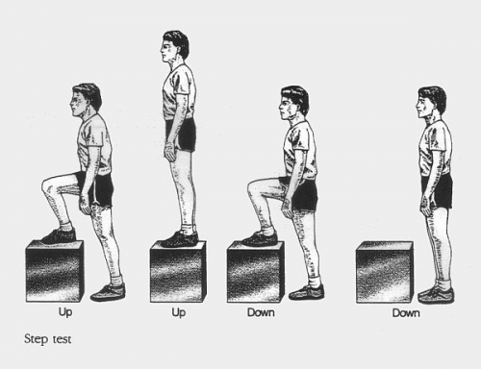**Diagram 1**: Picture showing one cycle of the step test.

***RESULTS & DISCUSSION***

1. Here is a table with results that were collected from the above experiment.

|  |  |  |  |  |  |  |
| --- | --- | --- | --- | --- | --- | --- |
| Test Subject | Heart Rate at different Intervals (beats/min) | | | | | Time for Heart Rate to return to resting heart rate level |
| 0 (Resting) | 3 | 6 | 9 | 12 |
| 1 | **73** | **122** | **141** | **134** | **128** | **4min** |
| 2 | **114** | **150** | **153** | **165** | **181** | **3min** |
| 3 | **64** | **108** | **85** | **101** | **109** | **2min** |
| 4 | **70** | **110** | **120** | **125** | **120** | **2min** |
| 5 | **79** | **123** | **114** | **96** | **90** | **4 min** |
| Average/ Mean |  |  |  |  |  |  |

2.Graph the heart rate at different intervals results on the separate graph paper [5 marks]

3. State a possible hypothesis for this experiment. [2 marks]

4. Determine the following - [2 marks]

INDEPENDENT VARIABLE:

DEPENDENT VARIABLE:

5. Suggest three possible variables that would have been controlled for the study to be a fair test. [3 marks]

6. Why is it important for the test subject to maintain the correct rate of exercise (1-2-3-4) during the experiment you carried out? [2 marks]

7. What was the purpose of taking the resting heart rate at the start of the experiment? [2 marks]

8. Suggest one way in which the study could be modified to increase its - [2 marks]

RELIABILITY:

VALIDITY:

9. (i) Of your sample, who appears to have the best cardiovascular fitness? [1 mark]

(ii) How do you know this? State specific information that provides the answer. [2 marks]

10. Using whole sentences, write a summary/discussion of your results in relation to the time taken for heart rate to return to resting heart rate levels. [4 marks]

11. What functions/processes does heart rate indicate are occurring within the body? [2 marks]

***Conclusion***

12. Write a conclusion for this experiment you. Remember to link the hypothesis with specific data in your response. [3 marks]

13. If someone else wanted to do a similar experiment, what suggestions could you recommend so that they can continue the research on the effect of exercise on heart rate? [2 marks]

Part Two [11 Marks]

You read the following hypothesis in an advertisement “A regular exercise program will increase cardiovascular fitness.”

After reading this you decide to design an experiment to test this hypothesis.

16. Over how many weeks will you run your experiment? [1 mark]

17. What form/s or type of exercise will your test subjects complete? [2 marks]

18. How frequently will subjects exercise and for what duration? [2 marks]

19. How many participants will there be? [1 mark]

20. Are there any particular characteristics that must be considered when selecting participants?

[3 marks]

21. What results do you think you will get? [2 marks]

***End of Assessment***